STUDY METARIAL NO… 36
FOR T.D.C PART- II (GEOGRAPHY HON’S)
Paper – 4th ( Economic Geography )
BY
Dr. ALPNA JYOTI
Deptt. of Geography, Marwari College, Darbhanga
LNM University, Darbhanga
Q. – WEBER’S INDUSTRIAL LOCATION THEORY

Introduction to the Weber’s industrial theory :-

Introduction :--------
Weber’s theory is based on the ‘least cost principle’, which is used to account for location of manufacturing industry. Weber’s approach is deterministic and normative. Weber aims to explain the location of industrial activity in term of three economic factor
- Transport costs
- Labour costs
- Agglomeration economies
His explanation is based upon finding the cost point for production.
Weber’s Assumption
The main assumption are as follow---
- The unit of analysis is a single, isolated country that is homogenous in term of climate, topography, race of people, technical skills of the people and is under one political authority.
- Transport cost are a function of weight and distance increasing in direct proportion to length of shipment and weight of cargo.
- Coast of land, building equipment, interest and depreciation of fixed capital do not vary.
- The size and location of centres of consumption of the industrial product are given. The markets, thus are point on the plain.
- There is an uneven distribution of natural resources on the plane. The location of source of raw materials are assumed to be known.
- Labour is geographically fixed.
- The entrepreneurs seek to minimise the total cost of production.
- Condition of perfect competition exists whereby resource and markets are unlimited at their given location and no firm may obtain a monopolistic advantage from its choice of location.
Weber’s analysis of industrial location is divided into two major section –
- Identification of the point of minimum transport cost.
- A discussion of the circumstances under which production will be attracted away from this least cost point.
Least Cost location Principle
According to weber, there are three regional factors which affect the cost of production.
- The cost of raw material.
- The cost of transporting raw material.
- The cost of labour.
Cost of Raw material :
The cost of raw material varies according to the nature of the deposit and the difficulty of mining them. If the deposit are difficult to access and they have great overburden or one quite deep, then the cost would naturally be higher. On the contrary shallow deposit, which will be less difficult to mine, will have lower prices.
Cost of Transporting Raw Material :
The cost of transporting raw materials depend upon the nature of the raw materials, whether it is …
Ubiquitous :
One that is found every where such as water, air, clay etc.
fixed :
One that is found in a particular place, i.e has fixed location.
Pure :
Localised materials that enter to their full weight into the finished product .
Gross :
Localised material that implies only a portion of or none of their weight to the finished product. Fuel is an extreme type of gross material for one of its weight enters into the product
All these variations are reflected in the cost of transportation, so that regional factors effecting production are reduced to transport cost and labour cost. He identified another local factor called agglomeration or deglomeration economies.
Agglomeration economies to refer to saving of the individual plants that result from their operating in the same location. This might result from the common use of such activities as auxiliary industries, financial services, public utilities etc.
In the single firm location, these processes and services have to be carried out or born by the firm at a great cost individually. As more and more firm cluster, linkages increase there is increased flow of goods between plants, development of specialised labour force and saving due to bulk purchasing of materials and large scale marketing of product. Agglomeration economies can be attained when a firm increase its production or when many firm cluster together.

Least Transport Cost Point :
In the absence of spatial differences in the basic production costs, Weber observed that manufacturing plants will be located at the point where the total transport cost are minimised.
He suggested that transportation cost are in effect determined by two factors-----
- The weight of the material to be assembled together with the weight of the final product to be shipped to the market.
- The distance over which the materials and the product have to be moved.
The combination of these two elements result in a simple index of cost, the tonne km or tonne miles. The location problem is then, simplified to fined the point where the total tonne mileage is minimised for the particular production distribution process.

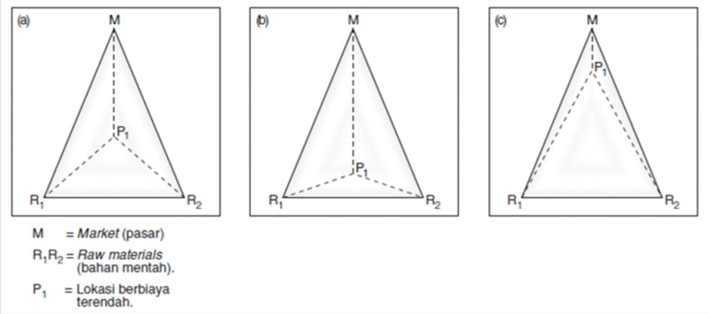
To fined the least transport cost location, Weber used simplified locational triangles, assuming two points where raw materials are found in a single market. From this locational triangle, angles a, b and c can be found.
In order to fined out weather industries are market oriented or raw material oriented, Weber devised a simple material Index (MI) formula.

Weight of the localised materials used in the industry
MI = ----------------------------------------------
Weight of the product
When there is no weight loss in the production, the material index equals 1, while when there is substantial weight loss; the material index is higher than 1.
Case 1 :- One Market One Raw Material
In the first case, a raw material to be produced at a different location (R) and the finished product made of material to be consumed at a different location (M). The problem is to determine where the manufacture or processing is to take place.
There are several possibilities :
- If the raw material is ubiquitous, then the factory will be located at the market, since at this, point the lowest transport costs would prevail on both material and product.
- If the raw material is fixed, then the factory can be located in either the market or at the source of the raw material.
- If the raw material is fixed and gross, then the factory will be located at the source of raw material.

Case 2 :---- One Market Two Raw materials
The second case assumes that raw materials are available at two places R1 and R2, at equal prices and the finished product to be consumed at M.
- If both R1 and R2 are ubiquitous, then the manufacturing will be at the market, since at this point, the transport cost on the both material and the product are the lowest.
- If the both raw materials are fixed and gross, the solution is complex, Weber sought to achieve this by the application of his locational triangle.
- If both raw materials R1 and R2 are fixed and pure, then the factory will be located at the market.
- If R1 is ubiquitous and R2 is fixed elsewhere than at the market and if both are pure, then the manufacturing will be at market.
Cost of market :-
If the same other place in the region, the cost labour per unit of product is less than it is at the optimum transport, perhaps because an established industry closed down or unusually high rate of population growth occurred or a pull of particularly skilled worker is available and if the increment to transport costs at this alternative location is less than the labour savings a deviation from the optimum least transport cost location will arise.

Role of Agglomeration :----
The coming together or agglomeration of industries offer cuts in production costs, if two or more industries operate in the same location.
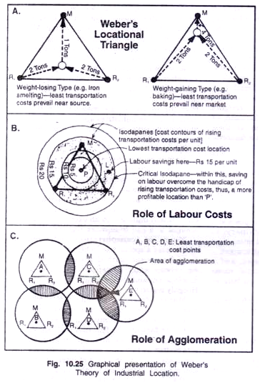
Criticism :----
Weber’s theory identified certain basic influences on the industrial location, it is open to criticism. Its value is now limited partly because of certain inherent weakness in the theory and partly because circumstance have changed, since the turn of the century, when Weber published it.
- Many of the assumption made by Weber are quite unrealistic.
- Perfect coemption rarely exists.
- Man does not always behave rationally.
- The market is in the form of point and one plant serve only one market.
- Weber’s material index was too crude a measure of transport cost which do not rise proportionally with distance and weight. Moreover, transport costs are rarely a basic criteria for the location of a frim today.
- Weber’s concentrated too much on minimising costs.
- Weber’s concept of the nature of industrial organisation and its decision making process is inconsistence with the condition is the modern industrial world.

---------------------0----------------------------------------

