What is Dielectric?
Dielectrics are non-conducting substances which are the insulating materials and are bad conductor of electric current. Dielectric materials can be made to hold an electrostatic charge while dissipating minimal energy in the form of heat. Examples of dielectric are Mica, Plastics, Glass, Porcelain and Various Metal Oxides and even dry air is also example of dielectric.
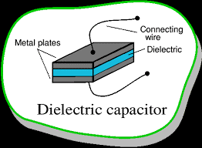
Figure (1) Dielectric capacitor

Classification of Dielectric?
Dielectrics can be classified as:
- Polar Molecules
- Non-Polar Molecules
Polar Molecules: Polar Molecules are those type of dielectric in which the possibilities that the positive and negative molecules will coincide with each other is null or zero.
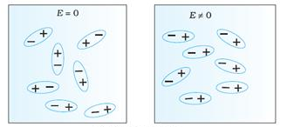
Fig(2) Coinciding polar molecules
The reason why the polar molecules do not coincide with each other is due to their shape, that is they all are asymmetric in shape.
Examples: H₂O, CO₂, NO₂ etc.
When the electric field is not present that is if it is absent then, it causes the electric dipole moment of these molecules in random direction which is responsible for cancellation of these molecules with each other. So, the average dipole moment is zero.
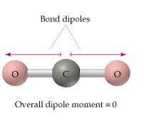
Fig (3) Dipole moment of polar molecules
If the external electric field is present, the molecules assemble in the same direction as electric field.
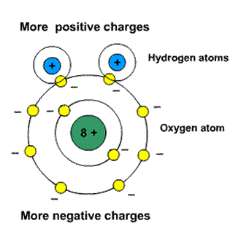
Figure (4) Polar Molecules
Non-Polar Molecule, unlike polar molecules in non-polar molecules the center of positive charge and negative coincide, that is it is not zero. The molecule then has no permanent (or intrinsic) dipole moment.
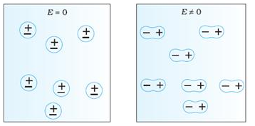
Fig(5) Coinciding Non-Polar molecules
Example: O₂, N₂, H₂ etc.
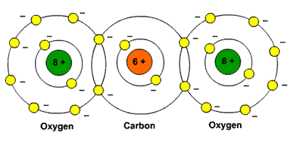
Figure (6) Non-polar Molecules

Induced Electric Dipole Moment
When in a non-polar molecule, all the protons are pulled in the direction as of electric field and electrons are pulled in opposite direction as of electric field, when an external electric field is applied. Due to the presence of electric field, this process continues unless the internal forces balance them. Due to this two centers of charge are created; the molecules are known as Polarized and is known as Induced Electric Dipole. The dipole moment is known as Induced Electric Dipole Moment.

polarisability
Applied field is directly proportional to induced dipole moment and is independent of the temperature. The direction of induced dipole moment (x) is parallel to the direction of electric field and for a single polar atom.
Polarizabilities determine the dynamical response of a bound system to external fields, and provide insight into a molecule's internal structure. In a solid, polarizability is defined as the dipole moment per unit volume of the crystal cell
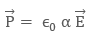
where 'a' is known as Atomic Polarisability

S.I. unit and dimensions of polarisability
The S.I. unit of polarisability is m³ and it’s dimensions as same as it’s volume.

Electric Polarisation
When a dielectric slab is placed in an electric field, then the dipole moment is gained by the molecule and the dielectric is said to be polarised.
The Electric Polarization is dipole moment per unit volume of a dielectric material.
The polarization is denoted by P.
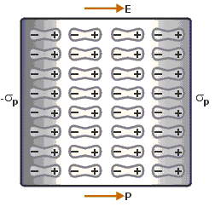 | 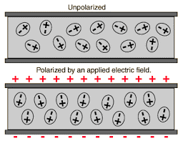
Figure (7) Polarisation | Figure(8) Polarisation Process

What is Dielectric Constant?
When Dielectric slab is placed between parallel plate, the ratio of the applied electric field strength to the strength of the reduced value of electric field capacitor is called Dielectric Constant that is:
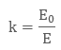
E is always less than or equal to E.
Where E_{o} is dielectric
And E is net field
The larger the dielectric constant, the more charge can be stored. Completely filling the space between capacitor plates with a dielectric increases the capacitance by a factor of the dielectric constant:
C = κ C_{o}, where C_{o} is the capacitance with no dielectric between the plates.

The Parallel Plate Capacitor
Parallel Plate Capacitors are the type of capacitors which that have an arrangement of electrodes and insulating material (dielectric). The two conducting plates act as electrodes. There is a dielectric between them. This acts as a separator for the plates.
The two plates of parallel plate capacitor are of equal dimensions. They are connected to the power supply. The plate, connected to the positive terminal of the battery, acquires a positive charge. On the other hand, the plate, connected to the negative terminal of battery acquires a negative charge. Due to the attraction charges are in a way trapped within the plates of the capacitor.

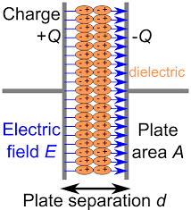

The Principle of Parallel Plate Capacitor
We know that we can give a certain amount of charge to a plate. If we supply more charge, the potential increases and it could lead to a leakage in the charge. If we get another plate and place it next to this positively charged plate, then negative charge flows towards the side of this plate which is closer to the positively charged plate.
As both the plates have charges, the negative charge on plate 2 will reduce the potential difference on plate 1. On the other hand, the positive charge on plate 2 will increase the potential difference on plate 1. But the negative charge on plate 2 will have more impact. So, more charge can be given on plate 1. Because of the negative charges on plate 2 the potential difference will be less. This is the principle of the parallel plate capacitor.

Dependence of Charge Stored in a Capacitor
The amount of electric charge stored in any of the plates of parallel plate capacitor is directly proportional to the potential difference between the two plates of Parallel Plate Capacitor. This relation can be seen as:
Q ∝ V
Therefore, Q = (constant)×V = CV
Where C = Capacitance of the capacitor; Q = Amount of charge stored in one capacitor; V = Potential difference between the two plates.

The Capacitance of Parallel Plate Capacitor
The capacitance of the parallel plate capacitor determines the amount of charge that it can hold. If you see the above equation, you will see that greater the value of C, greater will be the charge that a capacitor can hold. Therefore we can see that the capacitance depends upon:
- The distance d between two plates.
- The area A of the medium between the plates.
According to the Gauss law, we can write the electric field as:
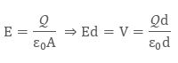
Since we know that the capacitance is defined as V = Q/C, so we can write capacitance as:
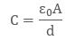
When the plates are placed very close and the area of plates are large, we get the maximum capacitance.

Effect of Dielectric on Capacitance
We usually place dielectrics between the two plates of parallel plate capacitors. They can fully or partially occupy the region between the plates. When we place the dielectric between the two plates of a parallel plate capacitor, the electric field polarises it.
The surface charge densities are σ_{p} and – σ_{p}. When we place the dielectric fully between the two plates of a capacitor, then its dielectric constant increases from its vacuum value.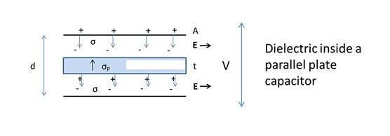
The electric field inside a capacitor is as follows:
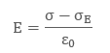
Hence we have:
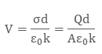
Therefore:
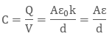
Ɛ is the permittivity of the substance. The potential difference between the plates is given by
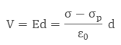
For linear dielectrics:
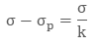
Where k is a dielectric constant of the substance, K = 1.
